**Oscar Alejandro Manzano**

**EE 4513 VLSI**

**Report Lab 6**

**October 10, 2019**

**For this lab, I learn how to build a XOR with NAND gates. It took four NAND gates to build it. After that I build a 1-bit Full Adder and for that it took two XOR’s, two AND gates, and one or gate. For the two and gates and the or gate, I transform into 3 nand gates. After building the 1-bit Full adder, I made an 8-bit Full Adder combining eight, 1bit full adders. After that I tested the 8 bit-Full Adder.**

**Fall 2019: EE 4513 Introduction to VLSI Design**

**Lab 6: Cadence Layout Lab Assignment**

**Objective:**

To implement the layout of combinational circuits using standard cells and verify their functionality.

**Tasks:**

Following are the tasks that you are required to perform:-

1. Create the layout for a 2 input XOR gate using Virtuoso. Use the 2 input NAND cell from your library to create the 2 input XOR cell. Use the diagrams below as a guideline. Verify the functionality of the XOR cell for all input combinations using the built in simulation tool.

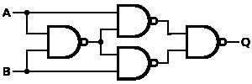

**NAND- NAND Realization of XOR function**

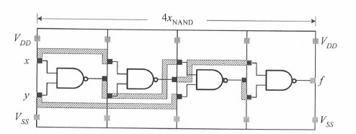

**2 input XOR cell constructed from four two-input NAND cells**

1. Using the 2 input XOR cell you created in Step 1 and other basic cells from your library, draw the layout for a Full Adder. Verify for functionality.

1

1. Using 8 such FAs (from Step 2) design an 8-bit adder.

1. Verify the functionality of the 8 bit adder using SPICE for at least four different input combinations. Also indicate the worst-case delay for your layout.

**Report:**

You should turn in a report containing the following items: -

1. Design approach adopted.
2. Snapshots of layouts and the corresponding simulation waveforms. Also, include the final gate-level schematic for each part mentioned above.

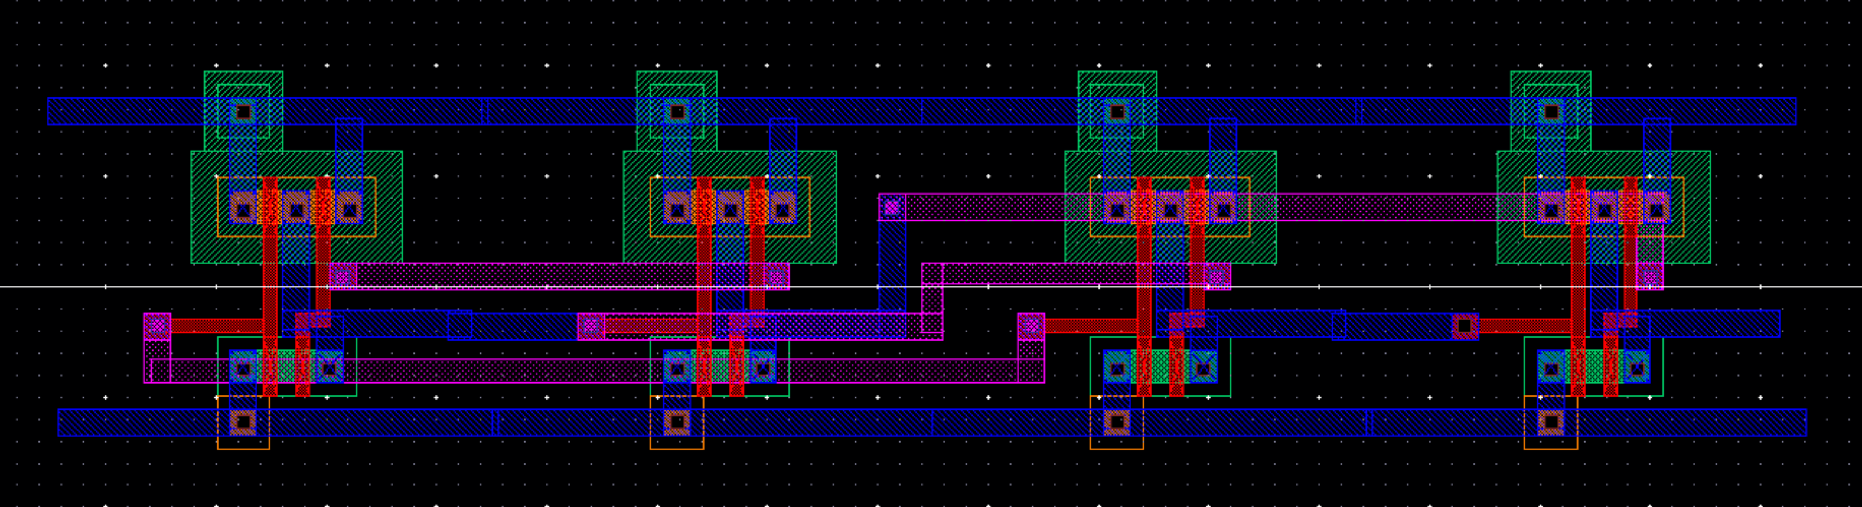 1.XOR

2.1-bit Full Adder

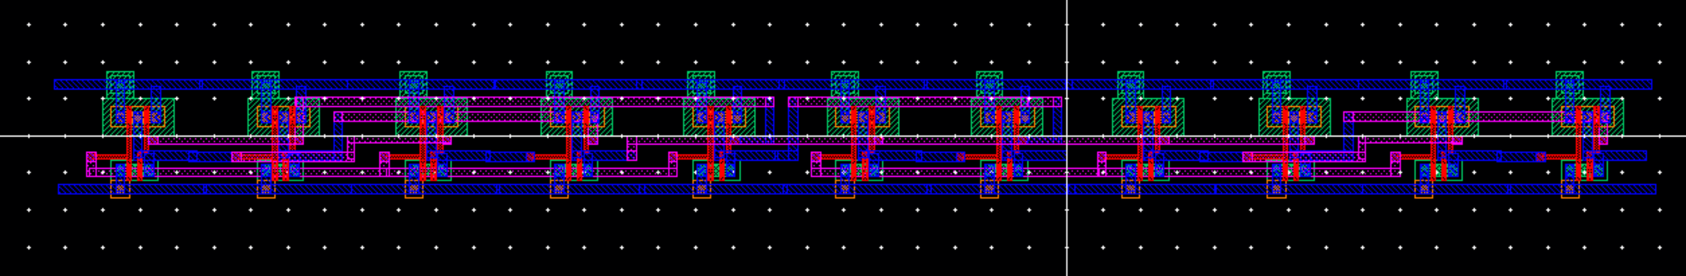

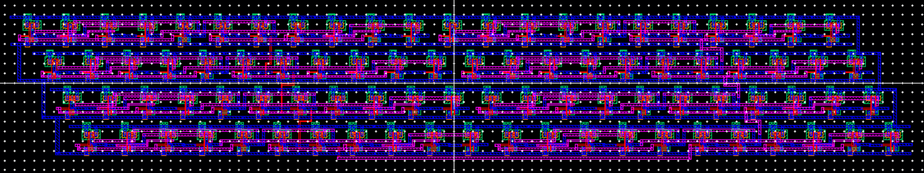3.8-bit Full Adder

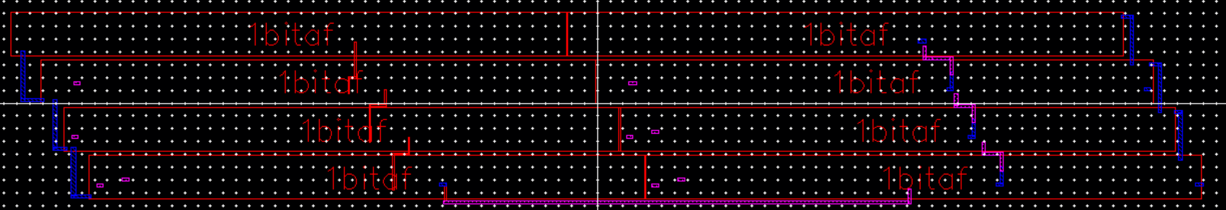8-bit Full Adder

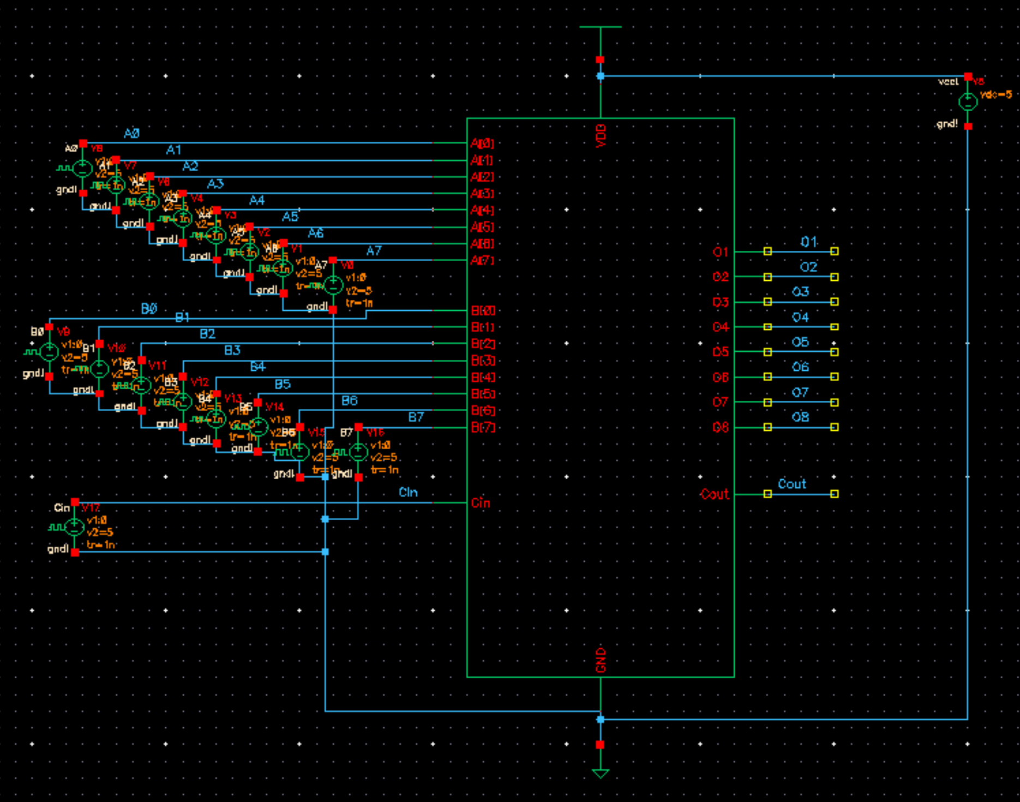

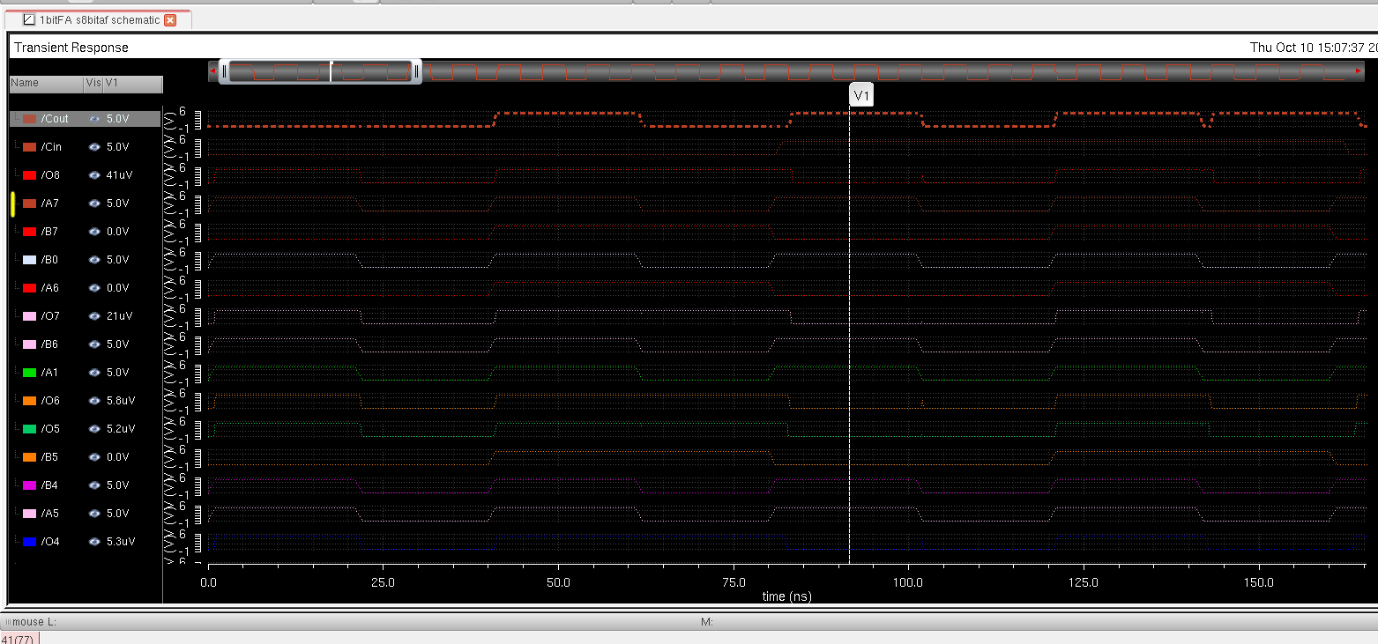Waveform

